horizontal line

**Ohio University**

174 Oxbow Trail,

Athens, OH 45701

Laser Light Show

**9th November 2022**

# PROJECT NEEDS AND GOALS

# Needs

1. Two player pong game that is projected by a laser.

# Goals

1. Create a system to control a laser to display an image.
2. Create a system to display a pong game using the laser.
3. Create a system to run our pong game.
4. Create a system to handle user input.
5. Develop a chassis to hold all subsystems.

# PROJECT STAKEHOLDERS

# Stakeholders

1. Daniel Allwine
2. Tianyi Cai
3. Ohio University

# Vendor

1. Laser light show team

# 

# 

# PROJECT SCOPE

Overall Scope of the project

# Objectives

1. Create a formalized plan for the laser light show design along with listing its constraints, requirements and deliverables.
2. Create a design and implement a plan for the project.
3. Establish a design in hardware, along with identifying a safe laser to use in given conditions.
4. Analyze the design of the project and fix any problems that arise.

# Constraints

1. The prototype is limited to a $500 budget, not including research costs.
2. Prototype must be completed by the senior design expo (April 13 2022).
3. Prototype cannot be dangerous to people around it while in operation

# Deliverables

1. A fully operational prototype of the laser light show.
2. A comprehensive design report, with enough detail documenting the entire design process and the complete design of the hardware, along with a thorough explanation of the software created for the project including a copy of the source code used for the program.
3. An operational manual for the lasers that contain enough detail with which a user can use the lasers and the game that is operated on it without resorting to trial and error and without external help.
4. Live demonstration of the fully developed prototype in the presence of an audience.

# 

# 

# 

# SYSTEM CONCEPT OF OPERATION

# Idea

The laser light show project will entail the projection of a game on a surface using a laser beam. The device will be able to be set up in similar fashion to a standard, consumer grade projector. However, due to the nature of video gameplay, there will also be game controllers used for human input.

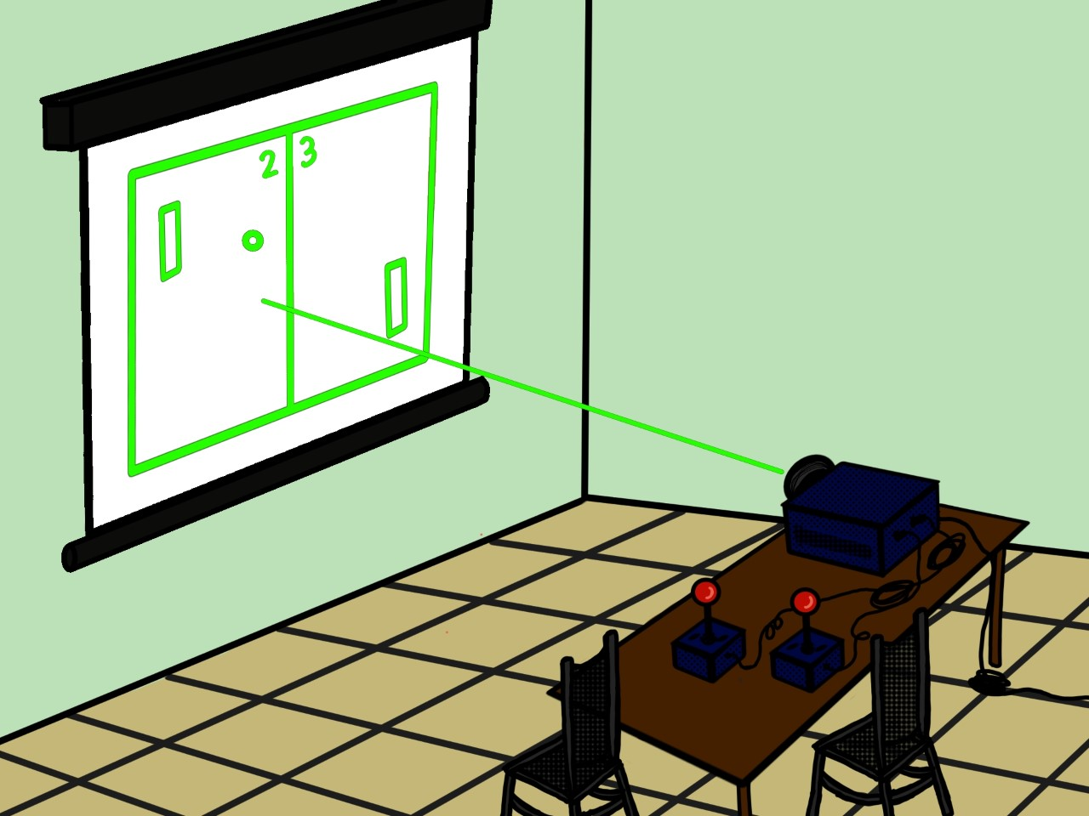

# Game Play

The game being displayed/played will be based upon the classic Atari 8-bit table tennis game called pong. Two players will each have wireless controllers in which they will be able to move a paddle projected on a medium. These paddles will interact with an animated ball that bounces off of the board and the paddles. The ball travels without friction and is only stopped if it travels past a paddle in which case the opposing player wins. Therefore, the objective of the game is to keep the ball from traveling past your own paddle.

# Projection

Projection of the game is by means of a laser. The device will manipulate a laser beam in a manner quick enough to fool the human eye. This allows the device to create drawings or animations using the moving beam.